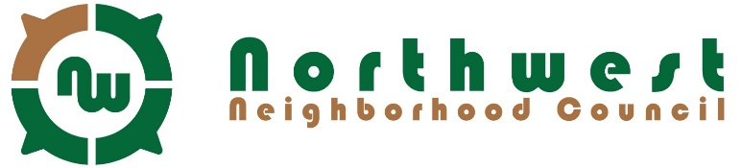
Regular Meeting Minutes
Wednesday, November 16, 2016, 7:00 PM

- Meeting called to order at 7:05 PM.
Voting Members Present: Beth Boquist; Wayne Clemm; Bill Codd; Diane Codd; Rick Colón; Kathy Fitchner; Theresa Morgan; Thomas Morgan; Nancy Painter; Larry Peck; J. Douglas Prendergast; Jeff Sevela
Non-Voting Members Present: Stephani Norby
- Secretary’s Report
Kathy read minutes from the October meeting.
A motion was made and seconded, approved unanimously.

- Chair’s Report
Doug read the agenda. A motion was made and seconded, approved unanimously.
- Treasurer’s Report
Balance is $1154.09. Payments were made of $80 total since last report.

- Committee Reports
- Beautification & Clean-up – Discussed multiple options, including dump passes. The use rate on dump passes is around 84%. Applications are due in March. Talked about having some sort of civic pride event, like displaying flags, or seasonal items in neighborhood.
- Grants & Finance – Community Development Block Grant (CDBG) allocations for 2016 need to be submitted soon. Discussed having a Papa Murphy’s Pizza fundraiser night or pizza at our concerts?
- Membership and Nominations – Doug reported that we currently have 53 members, 24 being voting members. We have 6 associate members. There are 12 voting members at this meeting and the quorum is met. All in attendance introduced themselves and gave a short self-history.
- Traffic & Transportation – Doug reported that applications are due in March 2017. Traffic calming project near Browne Elementary may start November 28th or next spring, weather permitting. We can submit two projects yearly; one residential and one arterial.
- Council’s Comments & Discussion
Next meeting date: Wednesday, January 18th, 2017, 7 PM
- Adjournment at 8:25 PM

Information archived online at Northwest.SpokaneNeighborhoods.org

